The Lord’s Service

The Resurrection of the Lord
April 5, 2026





Post Tenebras Lux

ORDER FOR THE WORSHIP OF GOD
PREPARATION FOR WORSHIP
PRELUDE
ANNOUNCEMENTS
SCRIPTURE MEDITATION: Colossians 3:1-4
If then you have been raised with Christ, seek the things that are above, where Christ is, seated at the right hand of God. Set your minds on things that are above, not on things that are on earth. For you have died, and your life is hidden with Christ in God. When Christ who is your life appears, then you also will appear with him in glory.
SILENT PRAYER
GOD CALLS US INTO HIS PRESENCE
† SALUTATION
In the name of the Father, and of the Son, and of the Holy Spirit.
Amen.
Alleluia! Christ is risen! Luke 24:34
The Lord is risen indeed! Alleluia!
† CALL TO WORSHIP: Isaiah 12:2-6
Behold, God is my salvation; I will trust, and will not be afraid; for the LORD GOD is my strength and my song, and he has become my salvation. ”With joy you will draw water from the wells of salvation. And you will say in that day: “Give thanks to the LORD, call upon his name, make known his deeds among the peoples, proclaim that his name is exalted. “Sing praises to the LORD, for he has done gloriously; let this be made known in all the earth. Shout, and sing for joy, O inhabitant of Zion, for great in your midst is the Holy One of Israel.”
†* HYMN OF PRAISE, NO. 286: “Worship Christ, the Risen King!”

† PRAYER OF ADORATION

† Congregation stands, if able | * Seating for latecomers at this time | All Scripture readings are from the ESV® Bible (The Holy Bible, English Standard Version®). ESV® Text Edition: 2016. Copyright © 2001 by Crossway, a publishing ministry of Good News Publishers. Assistive listening devices are available for use during worship services. Please inquire at the sound booth.

GOD CLEANSES US OF OUR SINS
CALL TO CONFESSION: Romans 5:9-10
Since, therefore, we have now been justified by his blood, much more shall we be saved by him from the wrath of God. For if while we were enemies we were reconciled to God by the death of his Son, much more, now that we are reconciled, shall we be saved by his life.
CORPORATE CONFESSION: (kneel as able)
Almighty God, in raising Jesus from the grave, you shattered the power of sin and death. We confess that we remain captive to doubt and fear, bound by the ways that lead to death. We fail to proclaim the gospel in word and deed, we ignore your call to discipleship. We overlook the poor and the hungry, and pass by those who mourn. Forgive us, God of mercy! Help us to trust your power to change our lives and make us new, that we may know the joy of life abundant, given in Jesus Christ, the risen Lord. Amen.
[Silent prayer of personal confession] Amen.

† ASSURANCE OF PARDON
† THE PEACE
† GLORIA PATRI (with hands lifted)
Glory be to the Father, and to the Son,
And to the Holy Ghost;
As it was in the beginning,
Is now, and ever shall be,
World without end. Amen, amen.
† HYMN OF PRAISE, NO. 267: “The Day of Resurrection!”
GOD CONSECRATES US BY HIS WORD
PRAYER FOR ILLUMINATION
OLD TESTAMENT LESSON: Isaiah 25:6-9 (sermon text)
The grass withers, the flower fades,
But the Word of our God will stand forever! Isaiah 40:8
NEW TESTAMENT LESSON: 1 Corinthians 15:51-58
This is the Word of the Lord
Thanks be to God!
† PSALM 22, NO. 368: “The Ends of All the Earth Shall Hear”
† GOSPEL READING: Mark 16:1-8
This is the Gospel of Jesus Christ
Praise be to you, O Christ!
PREACHING OF GOD’S WORD:
Swallowing Up Death
- Communion (v. 6)
- The Conquest (vv. 7-8)
- Consummation (v. 9)
† CONFESSION OF FAITH: Westminster Larger Catechism Q&A 52
Q. 52. How was Christ exalted in his resurrection?
A. Christ was exalted in his resurrection, in that, not having seen corruption in death (of which it was not possible for him to be held) and having the very same body in which he suffered, with the essential properties thereof (but without mortality and other common infirmities belonging to this life) really united to his soul, he rose again from the dead the third day by his own power; whereby he declared himself to be the Son of God, to have satisfied divine justice, to have vanquished death, and him that had the power of it, and to be Lord of quick and dead: all which he did as a public person, the head of his church, for their justification, quickening in grace, support against enemies, and to assure them of their resurrection from the dead at the last day.
Acts 2:24, 27; Luke 24:39; Rom. 6:9; Rev. 1:18; John 10:18; Rom. 1:4; Rom. 8:34; Heb. 2:14; Rom. 14:9; 1 Cor. 15:21-22; Eph. 1:20, 22-23; Col. 1:18; Rom. 4:25; Eph. 2:1, 5-6; Col. 2:12; 1 Cor. 15:25-27; 1 Cor. 15:20.
PRAYER OF INTERCESSION
OFFERTORY
† DOXOLOGY (with hands lifted)
Praise God from whom all blessings flow;
Praise Him all creatures here below;
Praise Him above, ye heavenly host;
Praise Father, Son, and Holy Ghost. Amen
GOD COMMUNES WITH US AT HIS TABLE
† SURSUM CORDA
Lift up your hearts.
We lift them up to the Lord.
Let us give thanks to the Lord our God.
It is right to give our thanks and praise.
It is right, and good, and a joyful thing, that we should at all times and in all places give thanks to You, holy Lord, almighty Father, everlasting God, through Jesus Christ our Lord. Therefore with angels and arch angels and with all the company of heaven we praise and magnify Your glorious name, evermore praising you and singing …
† SANCTUS
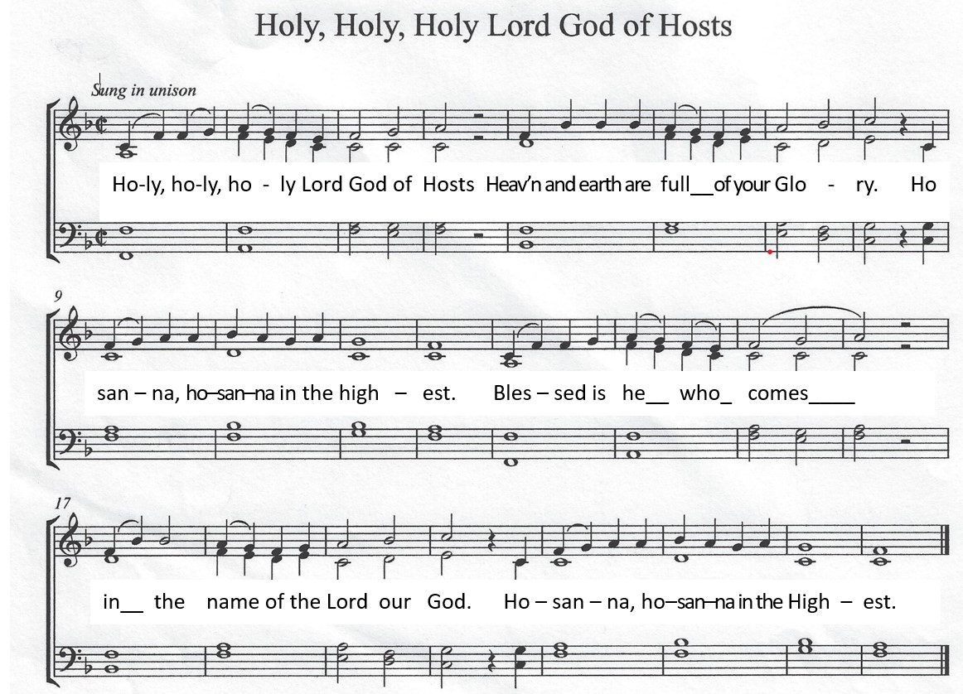
† PRAYER OF THANKSGIVING AND THE LORD’S PRAYER
Our Father, Who art in heaven, Hallowed be Thy name.
Thy kingdom come. Thy will be done on earth as it is in heaven.
Give us this day our daily bread. And forgive us our debts,
As we forgive our debtors. And lead us not into temptation,
But deliver us from evil: For Thine is the kingdom,
And the power, and the glory forever. Amen.
EUCHARISTIC MEDITATION
PRAYER OF CONSECRATION
WORDS OF INSTITUTION
Distribution of the Bread and Communion in the Body of Christ
Communion Meditation Silence
Distribution of the Cup and Communion in the Blood of Christ
Communion Song: “In Christ Alone” (printed on page 8)
PRAYER OF BLESSING
GOD COMMISSIONS US TO GO INTO THE WORLD
† HYMN OF PRAISE, NO. 277 “Christ the Lord Is Risen Today”
† BENEDICTION: Revelation 1:4b-5
Grace to you and peace from him who is and who was and who is to come, and from the seven spirits who are before his throne, and from Jesus Christ the faithful witness, the firstborn of the dead, and the ruler of kings on earth.
† THREE-FOLD AMEN
† POSTLUDE

In Christ Alone
Verse 1
In Christ alone my hope is found
He is my light my strength my song
This Cornerstone this solid Ground
Firm through the fiercest drought and storm
What heights of love what depths of peace
When fears are stilled when strivings cease
My Comforter my All in All
Here in the love of Christ I stand
Verse 2
In Christ alone who took on flesh
Fullness of God in helpless babe
This gift of love and righteousness
Scorned by the ones He came to save
Till on that cross as Jesus died
The wrath of God was satisfied
For every sin on Him was laid
Here in the death of Christ I live
Verse 3
There in the ground His body lay
Light of the world by darkness slain
Then bursting forth in glorious Day
Up from the grave He rose again
And as He stands in victory
Sin's curse has lost its grip on me
For I am His and He is mine
Bought with the precious blood of Christ
Verse 4
No guilt in life no fear in death
This is the power of Christ in me
From life's first cry to final breath
Jesus commands my destiny
No power of hell no scheme of man
Can ever pluck me from His hand
Till He returns or calls me home
Here in the power of Christ I'll stand
CCLI Song # 3350395
Keith Getty | Stuart Townend © 2001 Thankyou Music Ltd
For use solely with the SongSelect® Terms of Use. All rights reserved. www.ccli.com
CCLI License # 11313639
Steve, Jennie, Afton, Bev, Linda in our classroom at Thelma Baker Element-ary School library.

